It was need of time or produces of deeply meditated thoughts of our visionary Chief Minister Shri Nitish Kumar and Vice Chancellor Prof. S.N. Guha that Aryabhatta Centre for Nanoscience and Nanotechnology came in to existence. It may seem like an ordinary research establishment but has many stories of sacrifices and indefatigable efforts nestled in it. Our Honourable Chief Minister was pondering over alternatives after being hived off from Jharkhand and our Honourable Vice Chancellor having 42 years long stint as a renowned academician was thinking over something new, exciting and attached directly to the society. Fortunately that day arrived very soon and it was on 17.03.2011 when Dr. Kamal Prasad, an established Scientist of Nano Science and Technology, was invited from T.M. Bhagalpur University to deliver the foundation day lecture. What a wonderful co-incidence! It was attended by the Honourable Chief Minister himself and his colleague Minister of Education along with Minister of Arts and Culture. Top bureaucrats and academicians of the city had also graced the occasion. The aura of promise of Nanoscience and Technology influenced our Honourable Chief Minister and he readily agreed to support the establishment of Nanoscience and Nanotechnology Centre at Aryabhatta Knowledge University and invited Dr. Prasad and his group colleagues to contribute towards an earliest possible establishment of the centre. Prof. S.N. Guha, our honourable Vice Chancellor, took this idea as a mission and pursued tirelessly and this is how his cherished dream got fructified in to reality. Fortunately, this is one of the first centres of this university and many more like: Aryabhatta Centre for Life Science & Technology; Aryabhatta Centre for Stem Cell Technology; Aryabhatta Centre for Astronomy, Astrophysics & Applied Mathematics; etc. are to be established very soon.

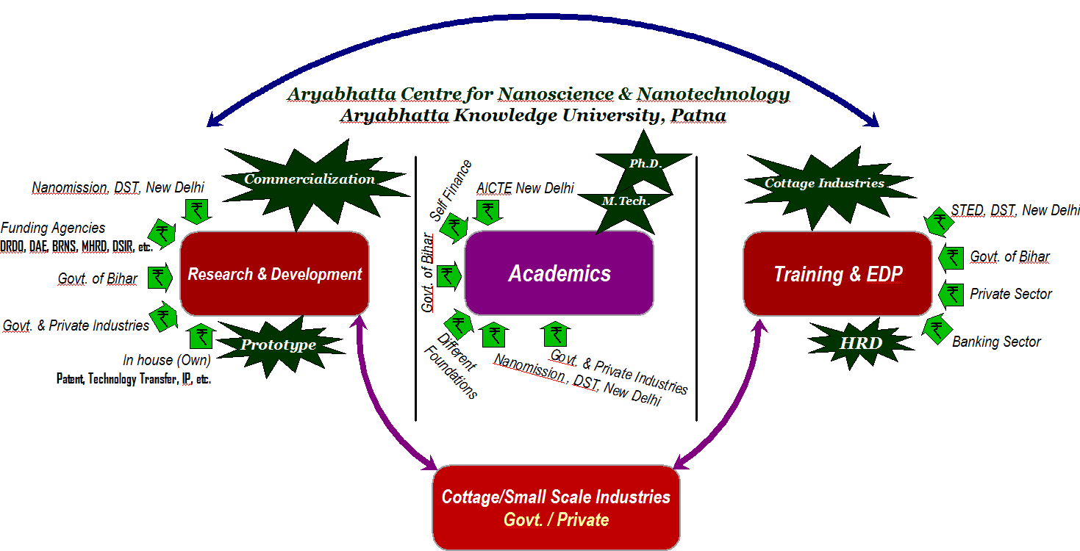

Vision 2020

Turning nanotechnology promise into commercial reality
Timeline for applications development
2013
2015
2017
2020

Academic Vision
The challenges posed by nanoscience and nanotechnology cannot be answered solely by principles and techniques derived solely from a single science or a technology discipline. Instead, it requires the contributions of diverse inter-related fields, but is not limited to, physics, chemistry, biology and engineering. Potential applications at the nanoscale may well provide for unprecedented benefits, but will require an even more diverse set of methodologies, especially for applications in medicine, agriculture, environment and electronics. Keeping in view the prodigal potentials of this upcoming area, Aryabhatta Knowledge University, Patna has initiated postgraduate (M.Tech. or M.S./M.Sc.) and research (Ph.D.) programmes in the area of nanoscience and nanotechnology. The rapid development and the exponential possibility of commercialization of the nano-based products warrants appropriate as well as acuminate development of human resource in this field. It is expected that this venture shall have major impact on the educational infrastructure as well as society too in the coming future.

Academic Programme: Aryabhatta Centre for Nanoscience & Nanotechnology offers following academic programmes:
- M.Sc. in Nano Science & Technology.
- M.Tech. in Nano Science & Technology.
- Ph.D. in Nano Science & Technology.

Faculty Profile

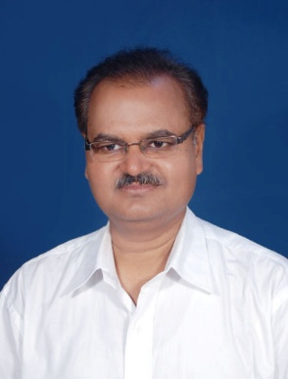
K. Prasad, M.Sc., PGDCA, Ph.D. is Professor & Head at Aryabhatta Centre for Nanoscience & Nanotechnology (ACNN), Aryabhatta Knowledge University, Patna. He also served as Associate Professor at the University Department of Physics, T.M. Bhagalpur University, Bhagalpur and Central University of Jharkhand, Ranchi, and in SLIET, Longowal (Punjab) India as Assistant Professor. He is also editorial board member of five international journals and life member of IACS Kolkata, MRSI Bangalore, IPA Mumbai, IC-ICTP Italy and American Nano Society (ANS) USA. He is also active referee of Czech Science Foundation and Latvian Council of Science and peer of about fifty reputed international journals. He was an INSA visiting fellow during 2004-’05. Dr. Prasad has successfully guided six Ph.D. students and handled seven major research projects including AICTE, DST and DRDO. He has (co-) authored over 150 publications including a book, three book chapters and three XRD-reference data in ICDD. He has presented papers and delivered invited lectures at major national/international conferences. Dr. Prasad has developed technology for the fabrication of nanomaterials based multipurpose face masks and indelible ink and a few green nanomaterials synthesis protocols and currently working on Wound healing lotion cum dressing gel and Online water filter system (along with Dr. Anal K. Jha). He is honorary technical consultant of Techsol International and Park Nano, Ranchi (Jharkhand). His current research interests include Green Nanotechnology, eco-friendly ferroelectric/piezoelectric ceramics and ceramic-polymer composites.

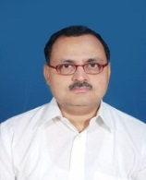
Dr. Anal K. Jha.Assistant Professor
Dr. Anal Kant Jha did his M.Sc. in Botany (Plant Physiology and Biochemistry) from Bhagalpur University in 1988 and M.Phil. in Biochemistry from the University of Cambridge, U.K. in 1990 as a benefeciary of the ODA Cambridge Scholarship, where he worked with the world pioneering group (Prof. Sir Peter Mensfield, N.L.; Prof. Peter Morris and Prof. D.H.Northcote, FRS) on MRI and applied this technique to development of plant system which was presented in the prestigeous Royal Society discussion meeting in 1990 and subsequently appeared in the Philosophical Transactions of the Royal Society, London, U.K. He was the first indian to have done that kind of pioneering work on NMR Microscopy of Plant System. After his return from the U.K. he obtained his Ph.D. in Plant Biochemistry in 1993 from T.M. Bhagalpur University.
He was lone asian to be invited to attend a workshop on Plant Molecular Biology in July 1994 by the University of London, U.K. He continued his post doctoral work till 1997 at University of Nottingham with Prof. Peter Mensfield and Peter Morris on MRI and on return he taught at Bhagalpur university. In 2001 he went to the JNU, New Delhi as Research Associate and worked on Plant Biotechnology at the School of Life Sciences. On return in 2002, he joined as faculty in the newly established Department of Biotechnology at Marwari College, T.M. Bhagalpur University till 2009. He started working on Nanobiotechnology from 2004 in active collaboration with Dr. Kamal Prasad, University Department of Physics, TM Bhagalpur University. He has 43 publications (31 in Nanoscience and Technology) 3 book chapters and many nano-based products and processes to his credit which are required to be patented soon. Dr. Jha has developed technology for the fabrication of nanomaterials based multipurpose face masks and indelible ink and a few green nanomaterials synthesis protocols and currently working on Wound healing lotion cum dressing gel and Online water filter system (along with Prof. K. Prasad). He is honorary technical consultant of Techsol International and Park Nano, Ranchi (Jharkhand). He is an active member of International Community on Nanoscience (Nanopaprika), Materiala Indica and a fellow of Cambridge Commonwealth Society, a distinction which he got from the Cambridge Commonwealth Society, Trinity College, Cambridge, U.K., for being awarded a Cambridge Fellowship in 1989.

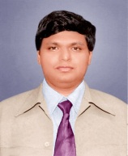

Rakesh Kr Singh Doctoral Alumnus of Patna University and he was born at Kasamra village of Purnea district of Bihar. At present he is an Assistant Professor, In the Centre for Nanoscience & Nanotechnology of Aryabhatta Knowledge University Patna. He has also Worked as a Assistant Professor in the Department of Physics, Patna Women's College, Patna University, Since August 2004 to August 2013. He did his Ph. D and Post-Doctoral work in Ferrite Magnetic Nanomaterials. Apart from Teaching-Learning & Evaluation and Co-curricular activities, he has guided, UGC-Sponsored Research Projects under 'College with Potential for Excellence' (CPE) status scheme, and Basic Scientific Research (BSR), UGC- Govt. of India, Special scheme (Total Projects: CPE: 09 and BSR: 07 = 16). He has been the Organizing secretary/ Conveners/ Coordinators of more than 60 conferences/ Seminars/ of International/ National repute along with keen interest in innovative Physics teaching in class room through low cost / No cost experiments. Presently he is working as a principal investigator on a UGC –Minor Research project on rare earth substututed Nanoferrite. Dr. Rakesh Kr Singh published more than 55 research publications/ Books/ Chapter in a book on Physics teaching, Research and Popularization in International/National Journals/ proceeding etc.
To his credit, he has received many recognitions / awards, such as : Senior Resource Person of of Utsahi Physics Teachers, coordinated by Prof. H.C.Verma, Dept. of Physics, IIT Kanpur in May 2009, Young Scientist Award in 1st Global Bihar Science Conference held at Patna Science College,
Patna University in May 2008, Master Resource Person of International Year of Physics – 2005, International year of Astronomy – 2009 (Trained by DST, Govt. of India and proclaimed by united nations) and invited by DST, Govt. of India to attend the Interactive meet of Nobel Laureates’ and Science Icons of European Union, Germany held Vigyan Bhawan, New Delhi on 8th February 2007.
He visited more than 40 academic instituations across the country as a Resource Person i.e in IIT’s, NIT’s , +2 Schools/ Colleges to nuture young minds for shaping society and Physics teaching/ Research interesting.
Research findings from thousands of credible published sources by Chicago, USA - High beam research( higheamresearch.com), One new finding in Nanotechnology reported by Rakesh Kumar Singh and co-authors is getting large no of citations at International level and is being cited by peer reviewed referred journals published from large no of countries that include Poland, Romania, USA, China, Italy, etc. Recently one research paper on Ni-Zn ferrite nanoparticles was also selected in among best 20 papers in Evans Library of Florida Institute of Technology, Melbourne, Australia.

He has academic linkage/ Collaboration/ Life membership with followings
(1) Senior Resource person of Utsahi Physics Teachers, coordinated by Prof. H.C.Verma, Dept. of Physics, IIT Kanpur,
(2). Society for Scientific Values, Delhi, 3. Science for Society, Bihar, member, NCSTC-network, Delhi (3). BBrain Devlopement Society,
(4). Magnetic Society of India, Hyderabad
(5). The Art of Living Foundation, India
(6). Indian Association of Physics Teachers and Anvesika ( Joint. Secretary, Bihar state unit )
(7). Indian Science Congress.

Admission Procedure
Candidates have to choose any one of the following papers for admission to Ph.D. programme depending upon their choice.
- Physical sciences
- Chemical sciences
- Biological sciences
- Engineering streams
The question paper will be divided into two parts of 50 marks each. Part-A will consist of fifty multiple choice questions on general science awareness type and Part-B will fifty multiple choice questions on the respective subjects. The syllabus can be seen on the university website.

No. of Seats: Notify time-to-time (includes reservation as per Government of Bihar norms).

Eligibility Criteria
The applicant should possess either (a) or (b) to pursue research in the broad fields of nanoscience and nanotechnology (see the Thrust Area of Research):
a. M.E./ M.Tech./ M.S. or equivalent degree with a minimum of 55% marks.
b. M.Sc. (in Nanoscience/Nanotechnology) or an equivalent degree in any branch of Physical/Chemical/Biological/Agricultural sciences with a minimum of 55% marks.

Thrust Area of Research
This major focus of this centre is to carry out researches in the frontier thrust areas of nanotechnology, which include:

- Biomedical sciences | - Nanobiotechnology
- Agriculture sector | - Food Technology
- Energy & Environment | - Defence need
- Healthcare & Cosmetology | - Nanoelectronics
- Nanoceramics and Nanocomposites | - Functional Nanomaterials

Application Fee
A demand draft of Rs. 500/- (Five hundred) from any nationalized bank should be submitted in favour of AKU Registration and Examination Fund payable at Patna.

Application Form
The application form can be downloaded from the University website http://akubihar.org. Each applicant should submit, in addition to his or her degree certificates, grade/mark sheets and other documents mentioned in the application, a Statement of Purpose (describing his or her research interests) together with the completed application, and mention up to three areas of interest in the order of preference for Ph.D. programme. Incomplete application form will be rejected. The completed application form along with all the documents and demand draft of Rs. 500/- should reach to the following address before 22.11.2013.
Registrar,
Aryabhatta Knowledge University
Chanakya National Law University Campus,
Mithapur, Patna – 800 001

Entrance Test and Interview
The applications will be screened and the selected applicants will be called for Pre-Ph.D. Registration Test (PRT) followed by personal interview. However the candidates having fellowships like UGC/CSIR-NET JRF, DBT-JRF, ICMR-JRF, INSPIRE, etc. are exempted from PRT.

Date of PRT: 10/12/2013

